

**Green University of Bangladesh**

**Department of Computer Science and Engineering (CSE)**

Faculty of Sciences and Engineering

Semester: (Fall, Year:2021), B.Sc. in CSE (Day)

**Lab Project Report**

Course Title: Data Structure

Course Code: CSE 106 Section: DB

**Project Name: Cyber-Café Management System**

**Submitted By:**

**Name: Samia Nowshin Oishi**

**ID: 211902009**

**Batch: 211**

**Submitted To:**

**Name : Md. Solaiman Mia**

**Department: Department of CSE**

**Submission Date: 28 December, 2021**

**[For Teachers use only: Don’t Write Anything inside this box]**

|  |
| --- |
| **Lab Project Status**  **Marks: ………………………………… Signature: …..................**  **Comments: …........................................... Date: …...........................** |

Table of Contents

**Chapter 1 Introduction Page**

* 1. Introduction -------------------------------------------------- 3
  2. Design Goals ------------------------------------------------- 3

**Chapter 2 Design/Development/Implementation of the Project**

2.1 Implementation---------------------------------------------- 4

**Chapter 3 Performance Evaluation**

3.2 Performance --------================------------ 13

3.4 Results and Discussions ---------------------------------- 18

**Chapter 4 Conclusion**

4.1 Introduction ------------------------------------------------ 18

4.3 Practical Implications ------------------------------------ 18

4.4 Scope of Future Work ------------------------------------ 18

**References** ----------------------------------------------------------- 18

**Chapter 1**

INTRODUCTION

* 1. **Introduction.**

The title of my Project is “CYBER-CAFÉ MANAGEMENT SYSTEM”.

This system will help the Cyber-Café administrator keeping their records easily. Here, I have created two different panel. One for the owners which is protected by password and one for the customer.

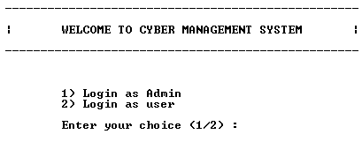

* 1. **Design Goals/Objective**

The main objective of the Cyber-cafe management system is to manage the details of ID Proof, Customers, Usage, etc. It contains all the information about Computers, and Customer ID. Only the administrator is guaranteed access full system. The project aims to create an application program to reduce the manual work for managing the bill, Computers, Customers.

**Chapter 2**

The Design Methods and Procedures

**2.1 Implementation**

The codes are written in C Language. I generate a file to store all the information.

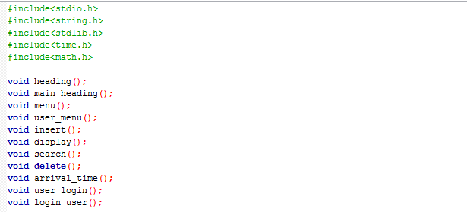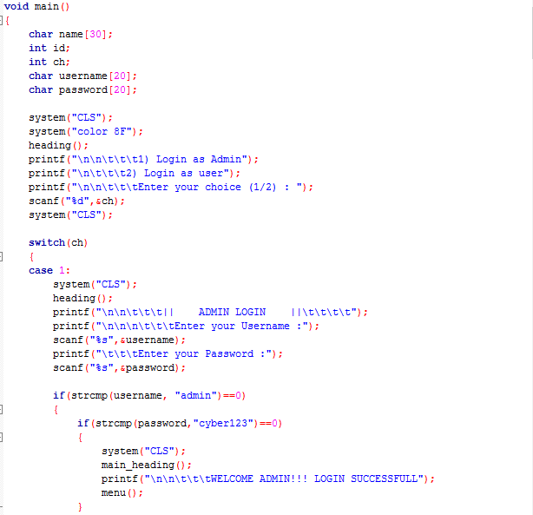

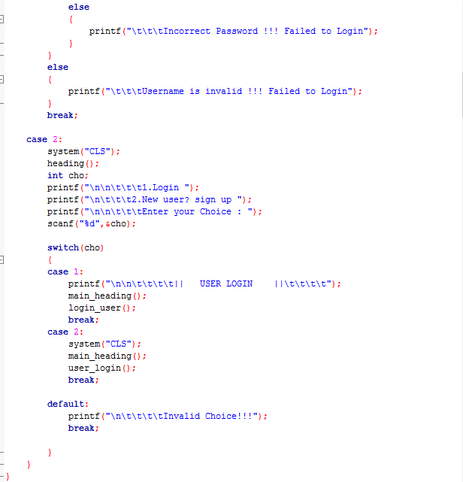

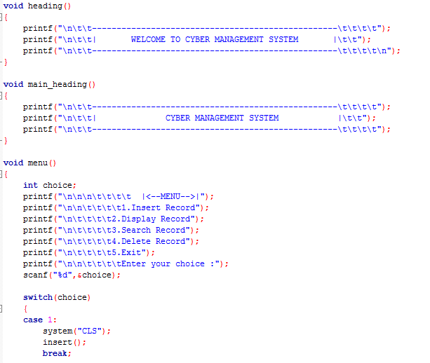

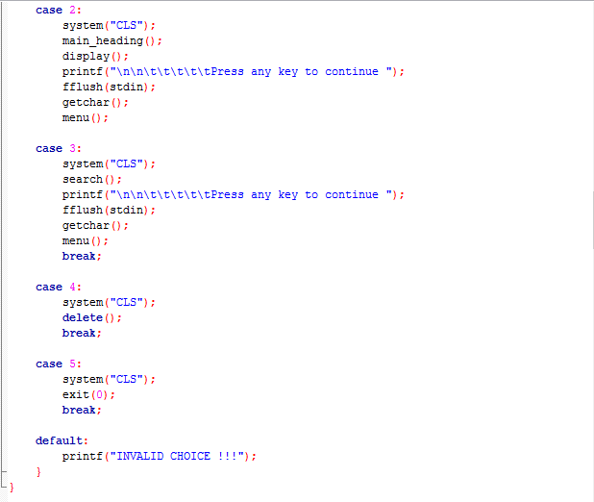

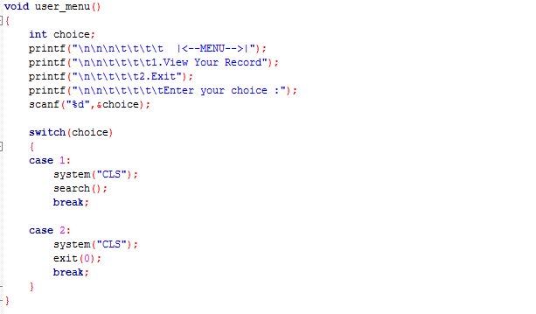

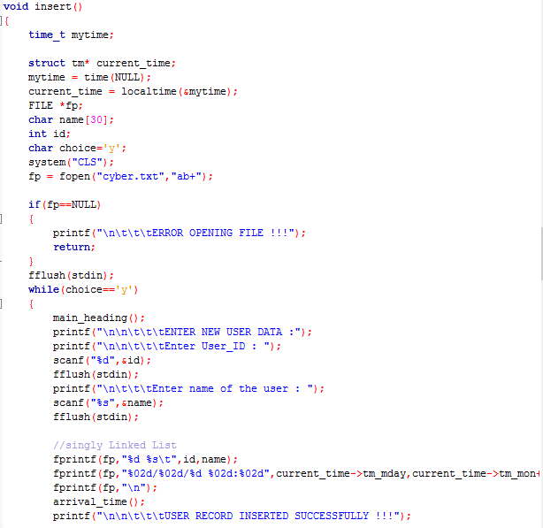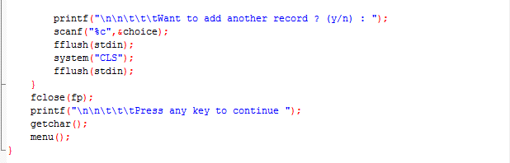

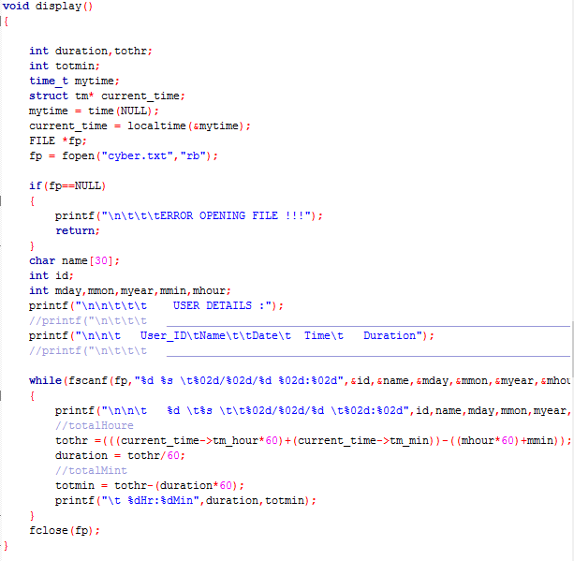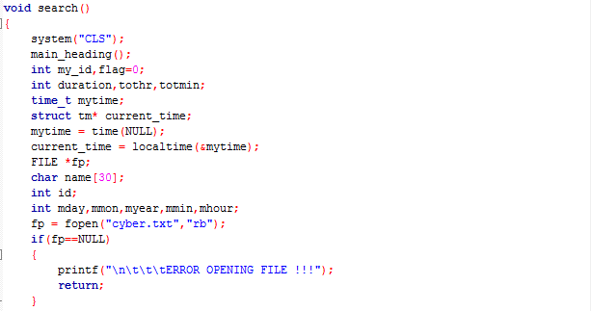

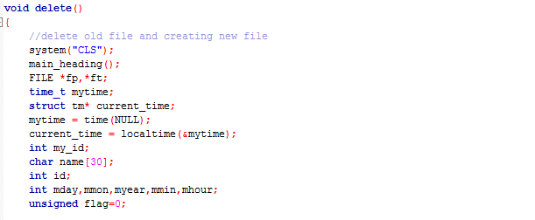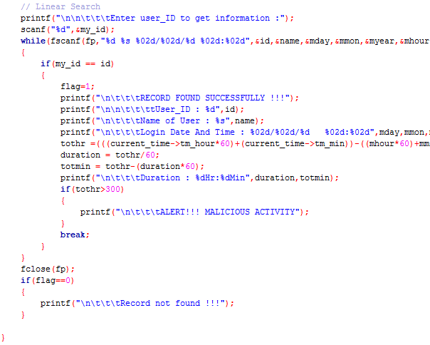

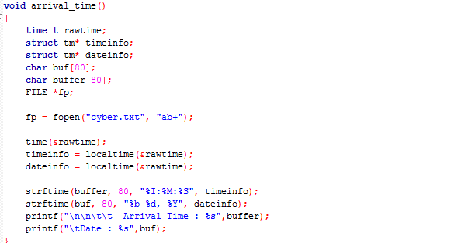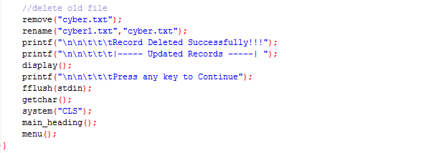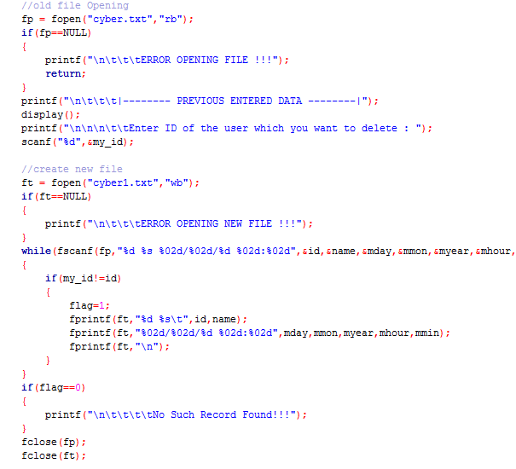

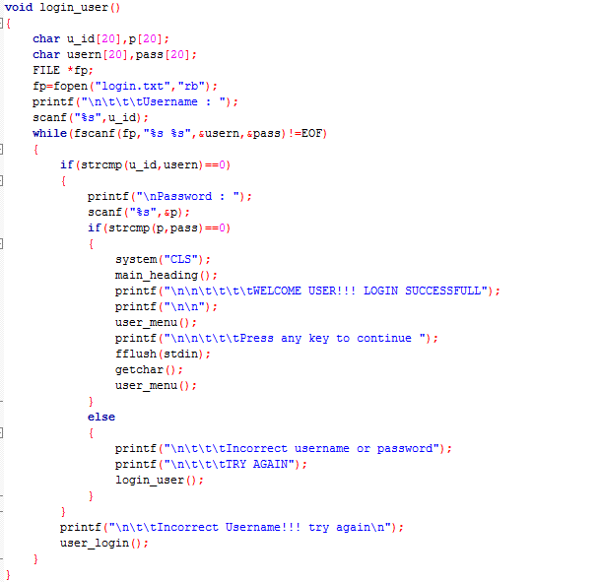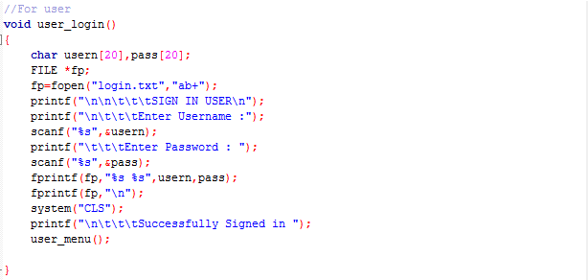

**Chapter 3**

Performance Evaluation

Here are the performances of my project…

Main Function:

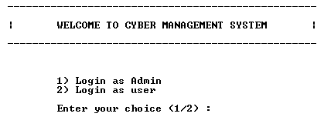

Admin Panel:

1

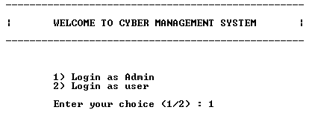

2

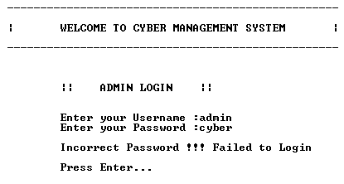

3

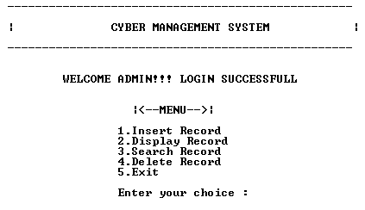

4

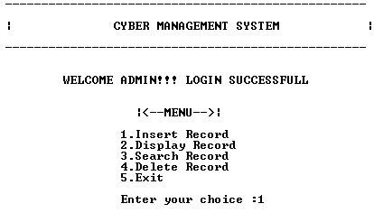

5

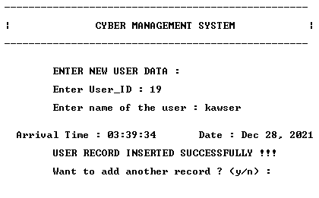

6

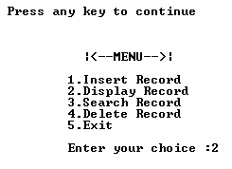

7

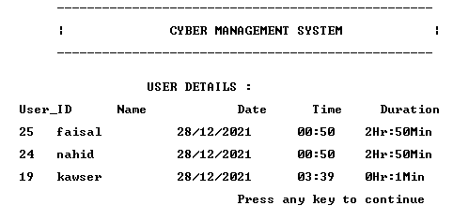

8

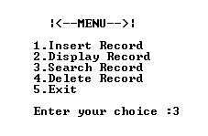

9

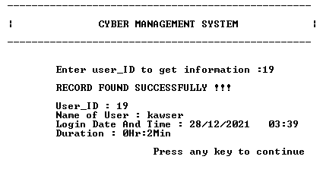

10

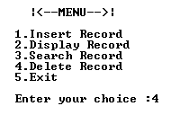

11

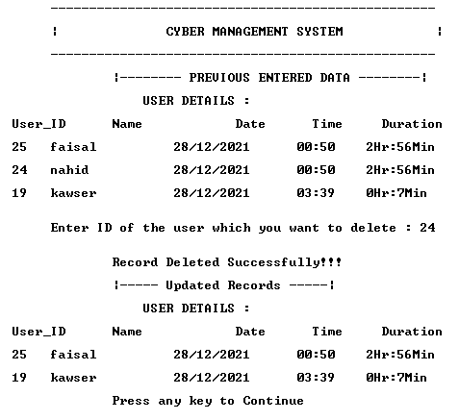

Customer Panel:

1

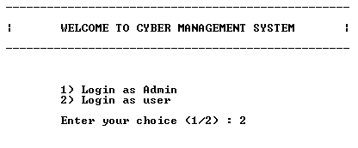

2

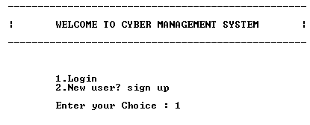

3

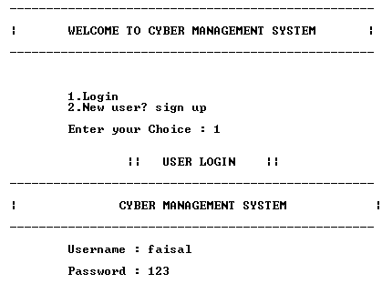

4

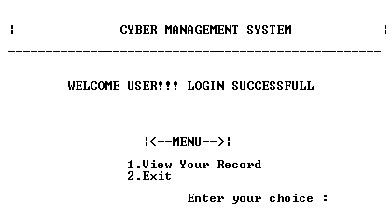

5

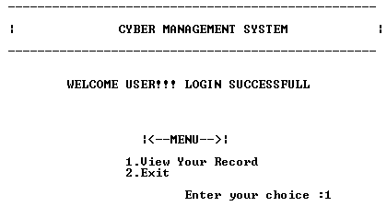

6

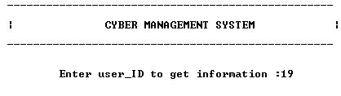

7

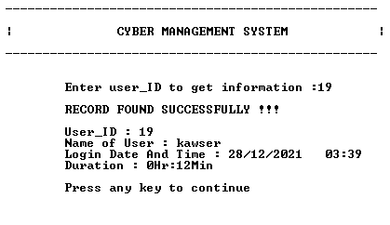

8

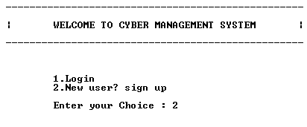

9

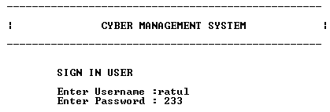

10

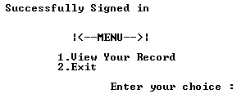

11

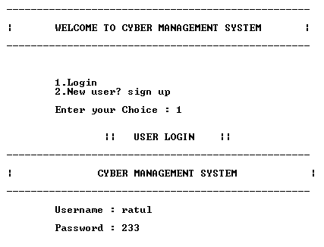

12

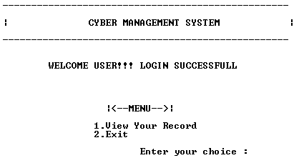

3.2 Basic Data

* C – Basic Datatypes.
* C – Variable Types.
* C – Operator Types.
* C – Input and Output.
* C – using Functions.

3.3 Results and Discussions

My project was working properly, though there were some bugs. But I achieved my goal.

Great skills have been achieved during the development of this project, time management is one of them, research in various areas of c programming and at the end of the day it can be said that the task has been a great success incorporated with challenges. These experiences will be used forever.

**Chapter 4**

**Conclusion**

4.1 Introduction

I have made this project in order to simplifies the task of the cyber-café. It is time consuming to write down the customer ID.

4.3 Scope of Future Work

This project is just a demo but this project has a huge future from my prospective. This project can be used as an application if file management system is implemented. After some simple modification, this project can be used for restaurant management, hotel management etc. I can also modify this project to manage our university’s canteen and library.

**References**

1. **https://www.tutorialspoint.com/eof-getc-and-feof-in-c**
2. [**https://www.programiz.com/c-programming/c-file-input-output**](https://www.programiz.com/c-programming/c-file-input-output)**)**
3. [**https://www.tutorialspoint.com/c_standard_library/time_h.htm**](https://www.tutorialspoint.com/c_standard_library/time_h.htm)